FADING

Fading in wireless communication refers to the variation in the strength of a signal received over a communication channel. This phenomenon is caused by various factors that affect the propagation of the radio waves. In this article, we are going to discuss fading in wireless communication.

What is Fading?
In wireless communication, fading is a process in which the strength and quality of a radio signal fluctuate over time and distance. Fading is caused by a variety of factors, including multipath propagation, atmospheric conditions, and the movement of objects in the transmission path. Fading can have a significant impact on the performance of wireless communication systems, particularly those that operate in high-frequency bands.
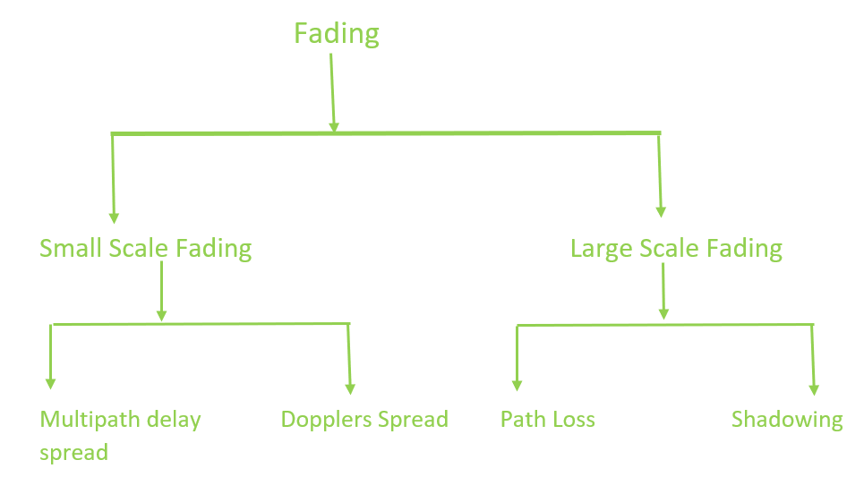
Fading In Wireless Communication

Types of Fading

1. Small Scale Fading
Small-scale fading is a common in wireless communication. It happens when a signal is transmitted from a transmitter to a receiver and it experiences multiple signal paths due to reflection, diffraction, and scattering from objects in the environment. These signal paths can cause interference and distortion to the signal, resulting in fluctuations of the signal strength at the receiver. Small-scale fading is called "small-scale" because the variations occur over short distances, such as a few centimeters to a few meters. Small-scale fading can happen very quickly, sometimes in microseconds or less.It is primarily caused by the multipath propagation of the signal. Overall, small-scale fading is a common issue in wireless communication that affects the quality of the received signal. However, with proper mitigation techniques, it is possible to maintain reliable communication even in the presence of small-scale fading.
1.1 Multipath Delay Spread:
Multipath delay spread is a type of small-scale fading that occurs when a transmitted signal takes multiple paths to reach the receiver.The different components of the signal can arrive at the receiver at different times, causing interference and rapid variations in signal amplitude and phase. Multipath delay spread can cause Inter-Symbol Interference (ISI), where symbols in the transmitted signal overlap and interfere with each other, leading to errors in the received signal. The root means square (RMS) delay spread is a measure of the dispersion of the signal and determines the frequency-selective characteristics of the channel.A higher RMS delay spread indicates a more frequency-selective channel, while a lower RMS delay spread indicates a flatter, more frequency-invariant channel.Multipath delay spread can be mitigated by using techniques such as equalization, diversity, and adaptive modulation. Equalization techniques are used to compensate for the time dispersion caused by multipath delay spread. Diversity techniques are used to combine multiple signal paths to mitigate the effects of fading. Adaptive modulation techniques are used to adjust the modulation scheme and data rate based on the channel conditions, allowing the system to adapt to changes in the channel and maintain a reliable communication link.
1.2 Doppler Spread
Doppler spread is a type of small-scale fading that occurs when there is relative motion between the transmitter and the receiver. The relative motion causes a shift in the frequency of the transmitted signal, known as the Doppler shift. The Doppler shift causes different frequency components of the signal to arrive at the receiver with different phases and amplitudes. This results in rapid variations in signal amplitude and phase, which can cause fading and errors in the received signal.
The Doppler spread is a measure of the rate of change of the Doppler shift and determines the time-varying characteristics of the channel. A higher Doppler spread indicates a faster time variation in the channel, while a lower Doppler spread indicates a slower time variation. Doppler spread can be mitigated by using techniques such as equalization, diversity, and adaptive modulation. Equalization techniques are used to compensate for the time dispersion caused by Doppler spread. Diversity techniques are used to combine multiple signal paths to mitigate the effects of fading. Adaptive modulation techniques are used to adjust the modulation scheme and data rate based on the channel conditions, allowing the system to adapt to changes in the channel and maintain a reliable communication link. Doppler spread is an important consideration in the design of wireless communication systems, particularly for mobile applications where there is often significant relative motion between the transmitter and the receiver.

2. Large Scale Fading
Large scale fading occurs when an obstacle comes in between transmitter and receiver. This interference type causes significant amount of signal strength reduction. This is because EM wave is shadowed or blocked by the obstacle. It is related to large fluctuations of the signal over distance. It is called "large-scale" because the variations occur over long distances, typically several kilometers. Unlike small-scale fading, which affects individual symbols or bits, large-scale fading affects the entire signal. Large-scale fading is a slow-varying phenomenon, meaning that it changes over time scales of seconds to minutes. Mitigation techniques for large-scale fading include power control, antenna placement, repeaters, and site diversity.Overall, large-scale fading is an important factor to consider in wireless communication system design, as it can significantly impact the quality of the received signal.
2.1 Path Loss
Path loss is the reduction in signal power as the signal travels from the transmitter to the receiver. It is caused by a variety of factors, including distance, the frequency of the signal, obstacles in the path of the signal, and the characteristics of the environment. The path loss is generally modeled using an attenuation equation that takes into account these factors. It is generally a slow-varying phenomenon and affects the overall received signal power. Path loss can be mitigated by increasing the transmitted power, using directional antennas, or reducing the distance between the transmitter and the receiver.
2.2 Shadowing
Shadowing is a type of large-scale fading that occurs due to the presence of obstacles or obstructions in the path of the signal.This causes the signal power to vary as the receiver moves in the environment. It is generally modeled as a log-normal distribution, with a mean and standard deviation that depend on the characteristics of the environment.
Shadowing is a slow-varying phenomenon and affects the overall received signal power. It can be mitigated by using techniques such as diversity, where multiple antennas are used to combine multiple signal paths, or by using signal processing techniques to estimate the shadowing effects and compensate for them.
.
Comparison between Small Scale fading and Large Scale Fading
Parameter | Small-Scale Fading | Large-Scale Fading
Time variation | Rapid | Slow
Cause | Multipath | obstacle
Distance | Within a few wavelengths | Over several wavelengths
Frequency | Affects individual symbols or bits | Affects the entire signal
Spatial variation | Significant variation over short distances | Gradual variation over long distances
Typical scale | A few centimeters to a few meters | Kilometers
Effect on signal | Can cause deep fades, interference, and distortion | Reduces the overall received signal power
Mitigation techniques | Equalization, diversity, adaptive modulation | Power control, antenna placement, repeaters, site diversity

